


Route 25
AGENDA FOR AUTONOMOUS, INTELLIGENT, INTEROPERABLE AND INCLUSIVE MOBILITY

Mariana Chaves Santos
14.11.2025

Monday – 10th November 2025

Tasks:

- Onboarding;

Tuesday – 11th November 2025

Tasks:

- Onboarding;

Wednesday – 12th November 2025

Tasks:

- Problem Understanding, Data Exploratory Analysis
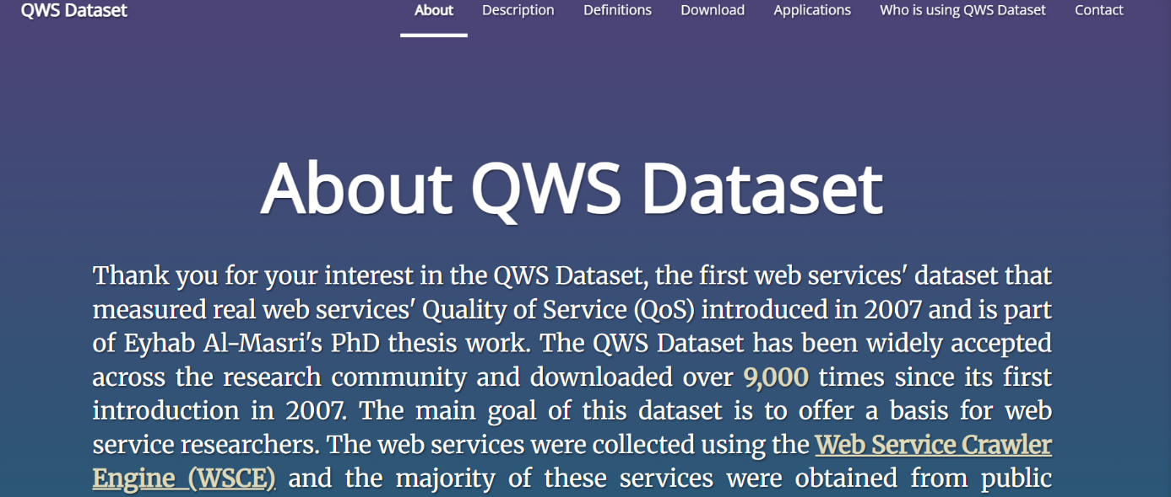

In this stage of the project, I focused on understanding the problem and performing an exploratory analysis of the available dataset. The goal was to ensure that the data supports the questions to be answered and to identify potential challenges before moving on to more complex steps.
We began by examining the structure of the dataset, checking the number of records, variable types, and the presence of missing values. Descriptive statistics and simple visualizations were used to understand variable distributions, identify patterns, and detect possible outliers. This analysis also helped assess data quality and formulate initial hypotheses about relationships between variables.
With these insights, we were able to gain a clear understanding of the context and define the next steps of the project with greater confidence.

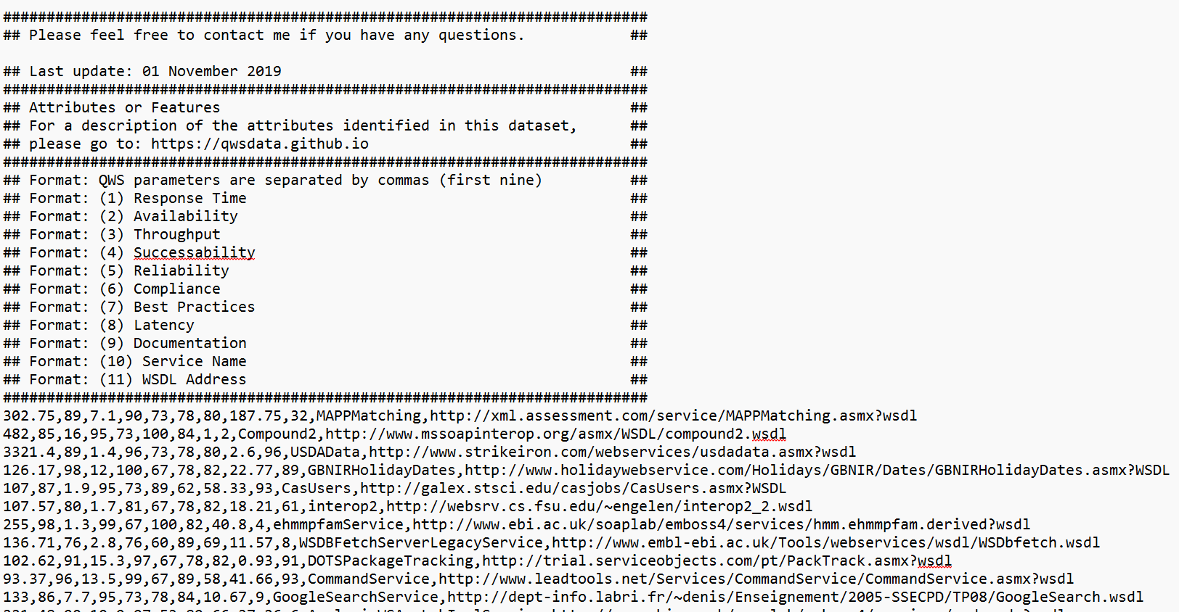

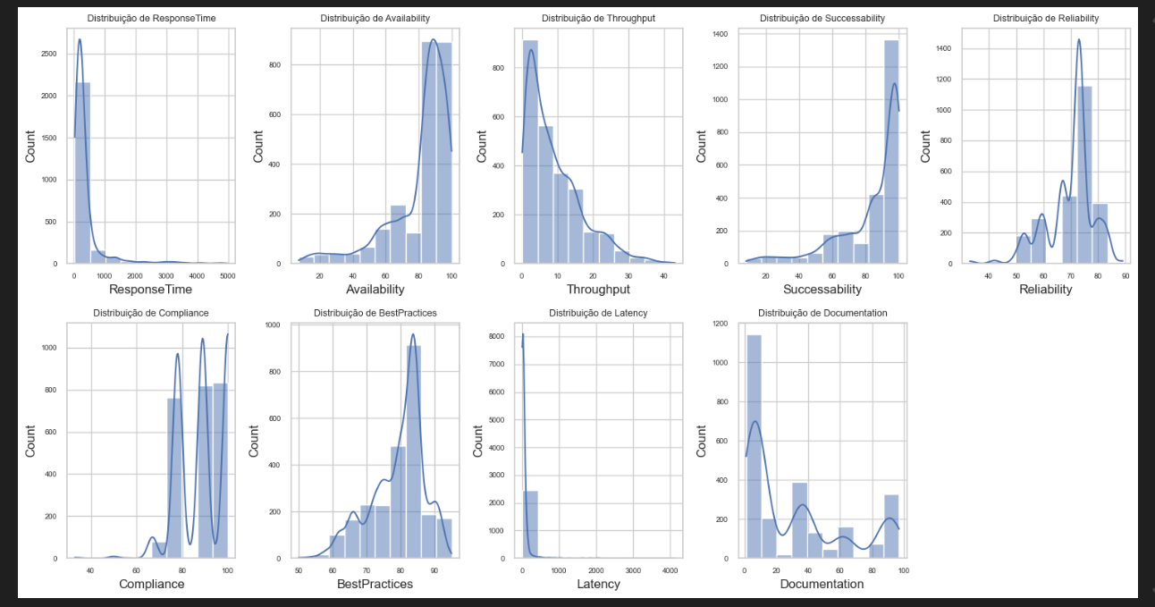
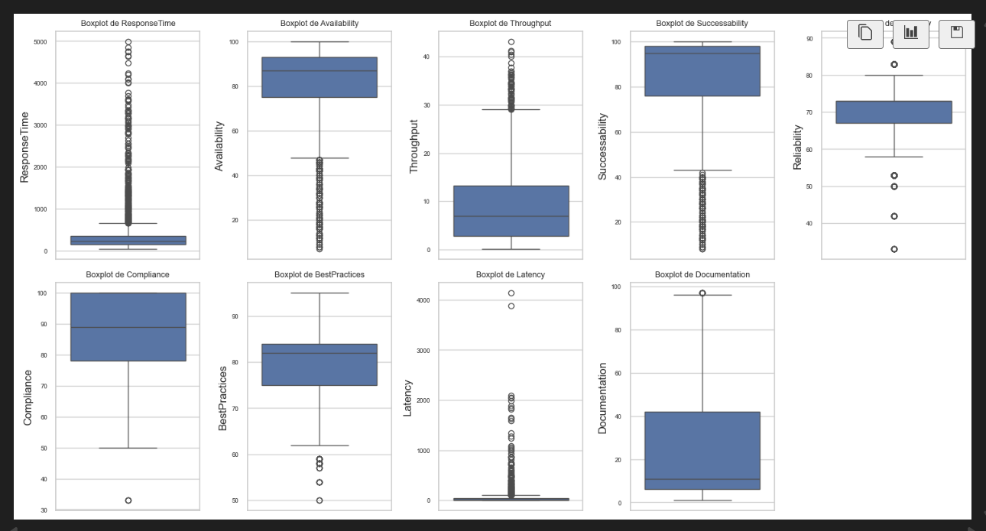
Thursday – 13th November 2025

Tasks:

- Data Processing, Train/test split, Baseline Model
In this phase of the project, I focused on preparing the data for modeling and establishing a baseline for performance evaluation. The process began with data preprocessing, which included handling missing values, encoding categorical variables, and normalizing numerical features where necessary. These steps were essential to ensure data consistency and improve model reliability. After preprocessing, the dataset was split into training and testing subsets to allow for unbiased model evaluation. This separation ensures that the model is assessed on unseen data, providing a realistic measure of its generalization capability.
Finally, a baseline model was implemented to serve as a reference point for future improvements. The baseline helps determine whether more complex models offer significant benefits compared to a simple approach. This step is crucial for setting expectations and guiding the development of more advanced solutions.

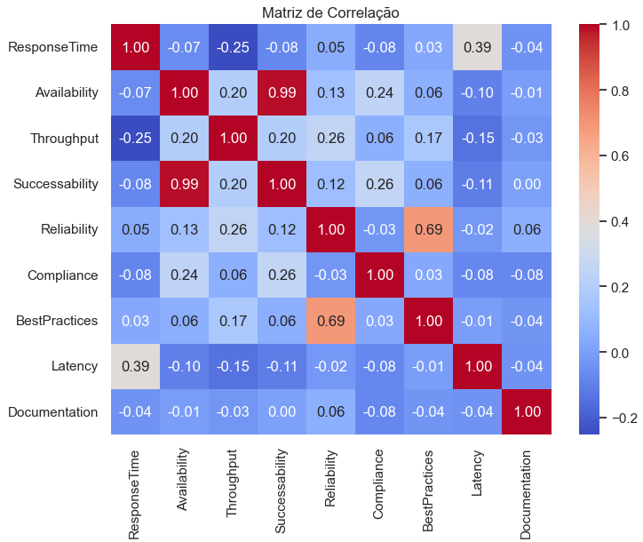
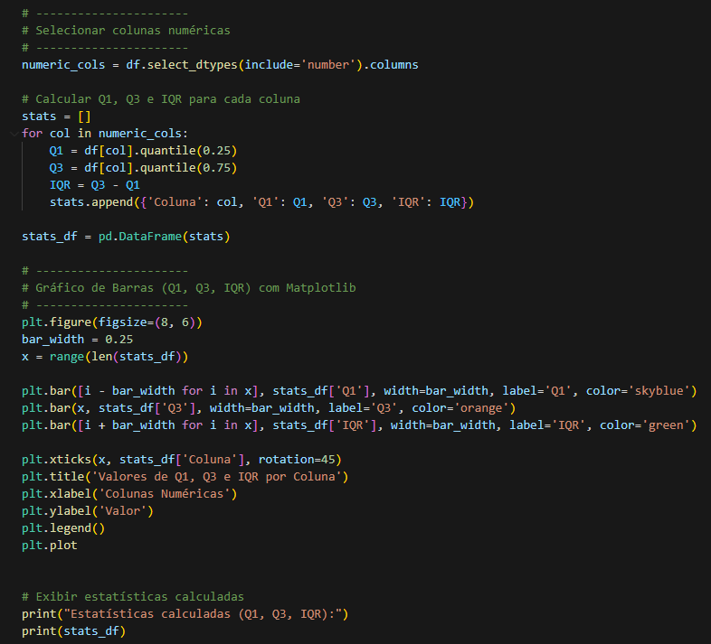
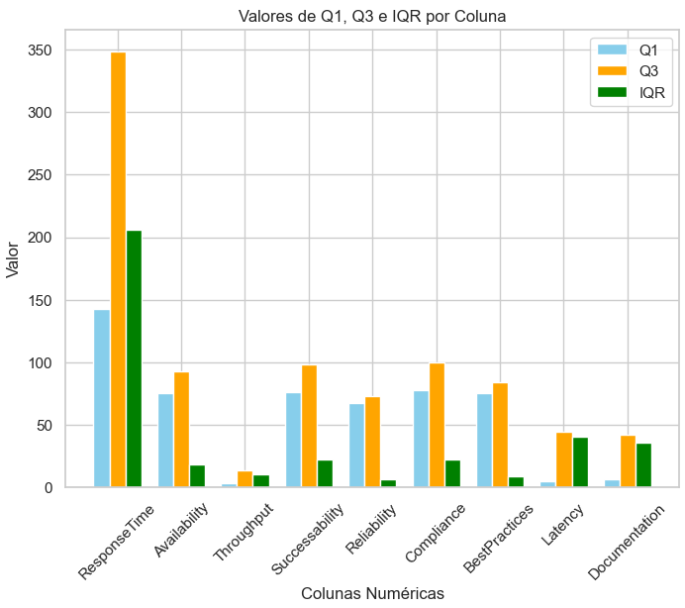

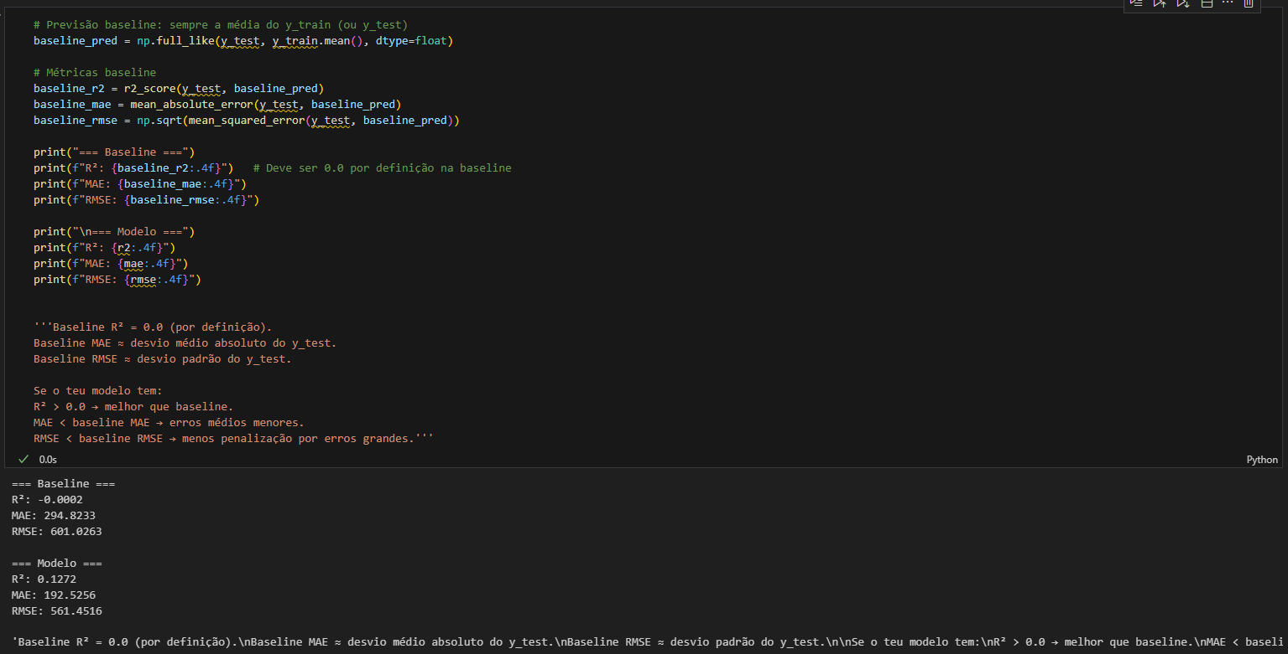
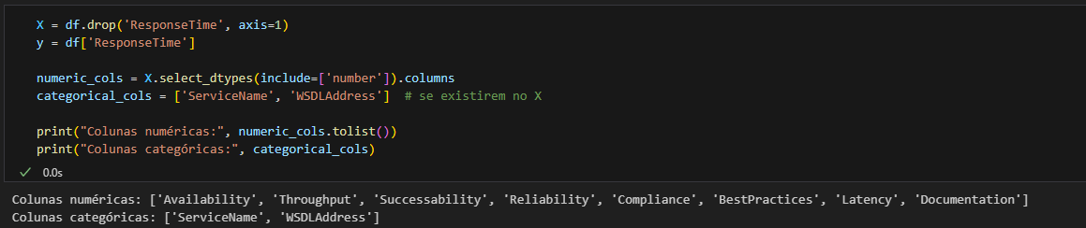

Friday – 14th November 2025

Tasks:

- Regression and classification models;
In this stage of the project, I focused on building and evaluating predictive models for both regression and classification tasks. The goal is to apply different algorithms to understand their performance and suitability for the problem at hand.
For regression, models were trained to predict continuous target variables, exploring techniques such as linear regression and more advanced approaches when necessary. For classification, the objective was to correctly assign observations to predefined categories, using algorithms like logistic regression, decision trees, and others.
Each model was evaluated using appropriate metrics for its type, ensuring a fair comparison and identifying strengths and limitations. This step provided valuable insights into which modeling strategies are most effective for the dataset and problem context.
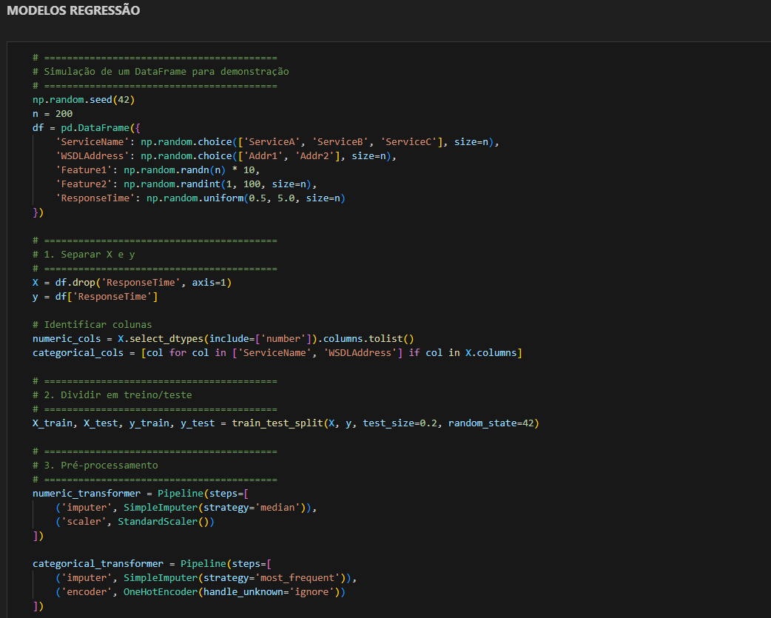
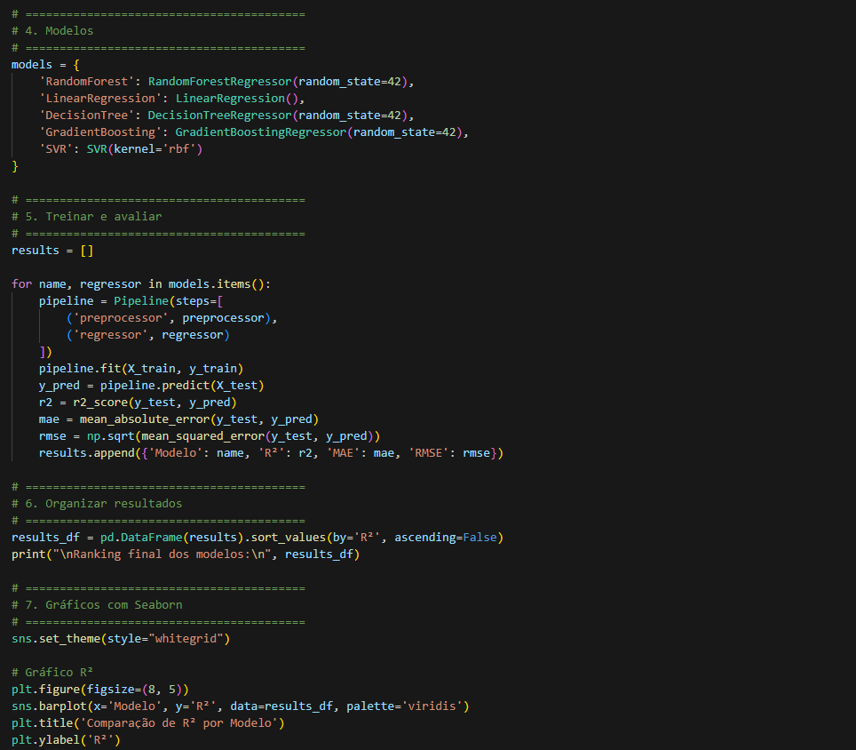

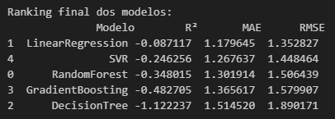

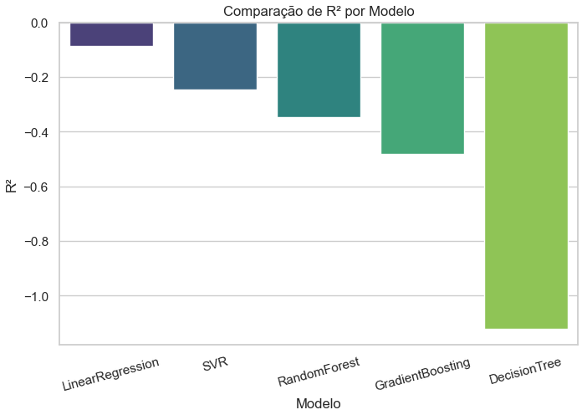
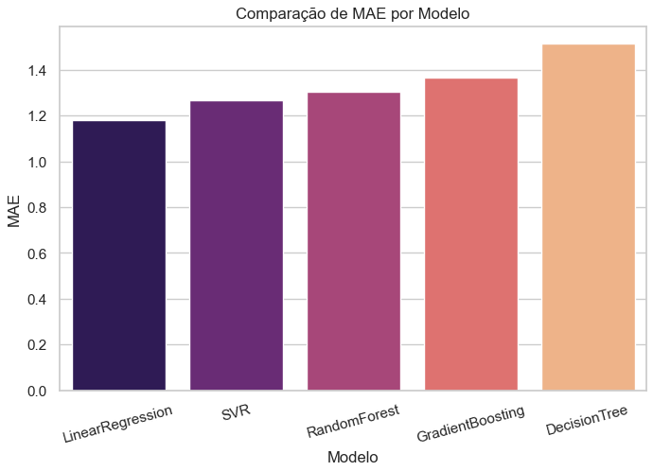

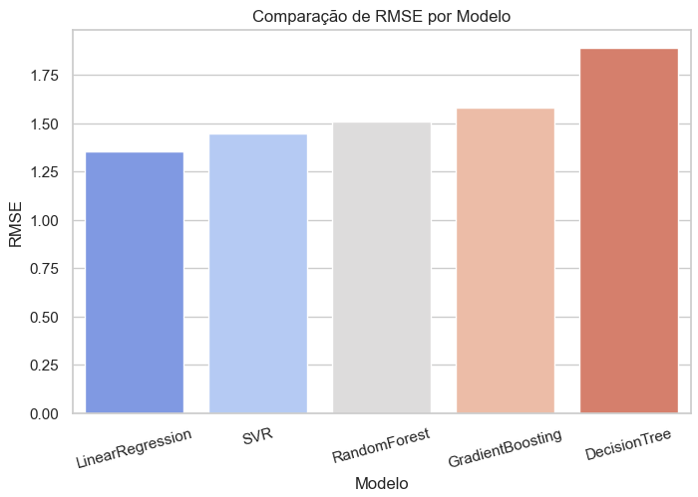

About Capgemini Engineering
World leader in engineering and R&D services, Capgemini Engineering combines its broad industry knowledge and cutting-edge technologies in digital and software to support the convergence of the physical and digital worlds. Coupled with the capabilities of the rest of the Group, it helps clients to accelerate their journey towards Intelligent Industry. Capgemini Engineering has 65,000 engineer and scientist team members in over 30 countries across sectors including Aeronautics, Space, Defense, Naval, Automotive, Rail, Infrastructure & Transportation, Energy, Utilities & Chemicals, Life Sciences, Communications, Semiconductor & Electronics, Industrial & Consumer, Software & Internet.
Capgemini Engineering is an integral part of the Capgemini Group, a global business and technology transformation partner, helping organizations to accelerate their dual transition to a digital and sustainable world, while creating tangible impact for enterprises and society. It is a responsible and diverse group of 340,000 team members in more than 50 countries. With its strong over 55-year heritage, Capgemini is trusted by its clients to unlock the value of technology to address the entire breadth of their business needs. It delivers end-to-end services and solutions leveraging strengths from strategy and design to engineering, all fueled by its market leading capabilities in AI, cloud and data, combined with its deep industry expertise and partner ecosystem. The Group reported 2023 global revenues of €22.5 billion.
Get the future you want | www.capgemini.com


This presentation contains information that may be privileged or
confidential and is the property of the Capgemini Group.
Copyright © 2024 Capgemini. All rights reserved.

